Newport High School Cluster
Transition Plan 2023-24

INTRODUCTION

This transition plan aims to support and develop links between Newport High School and the cluster primary schools with a specific focus on working together to support coherent learner progression, support the overall needs and well-being of the learner and ensure appropriate pace and challenge in a school’s approach to progression when developing their curriculum and assessment arrangements

Our ‘Rise Up’ transition programme focuses on 4 key principles to ensure all pupils in the Newport cluster rise through their learning journey feeling respected, independent, safe and equipped for secondary school.

The Newport Cluster is committed to:

- Respecting learner and parent views in a person-centred transition process
In the Newport High Cluster, we ensure that students are active participants in the transition process. We respect and understand the important role that students and their parents and carers have in the transition process and empower them with the confidence to articulate their learning needs in a new environment. We understand the importance of student and parent voice and its role in supporting an immersive transition process

- Encouraging Independence through reflection and purposeful design
In the Newport High Cluster, we believe improving curriculum continuity across the cluster to be a vital part of the transition process and are committed to providing staff with regular opportunities to collaborate across the cluster through shared meetings and professional learning opportunities as well as half termly opportunities to meet as Areas of Learning Experience. During these meetings staff focus on curriculum design and planning for learning and teaching as well as progression and assessment. We understand the importance of a shared understanding of how pupils learn in order to achieve a greater continuity in excellent teaching and learning experiences and progression.

- Ensuring safety and positive relationships
In the Newport High Cluster, we are committed to forging links with students and parents and carers across the continuum and to understanding the learning needs and the well-being of each individual learner. We understand the difference between the transition culture across the 3-16 continuum and the induction process and are focused on providing a variety of experiences to ensure students feel part of Newport High school and have established positive relationships with staff and pupils long before they commence Year 7. We recognise, appreciate and celebrate the diversity of our community.

- Being ready and equipped to support

In the Newport High Cluster, we ensure the efficient and regular liaison between Newport High School and the cluster primaries. This communication between the cluster involves the sharing of core information and data to support the transition and induction process. Managing and co-ordinating of transition is led by Miss A Milton (Assistant Headteacher). To ensure our cluster objectives are achieved and that transition is effective and supports for all students and their families the transition plan will be evaluated annually.

This plan has been constructed jointly by the leadership teams and governing bodies of: Newport High School; Crindau Primary School; Malpas Church Primary School; Malpas Court Primary School; Malpas Park Primary School; Millbrook Primary School and Monnow Primary.

This transition plan is effective for the Y7 cohort of September 2023 and was reviewed in September 2023.

In the Newport Cluster Transition activities begin when students reach Year 4 of their respective primary schools. The transition roadmap below outlines the opportunities that learners experience from Year 4.

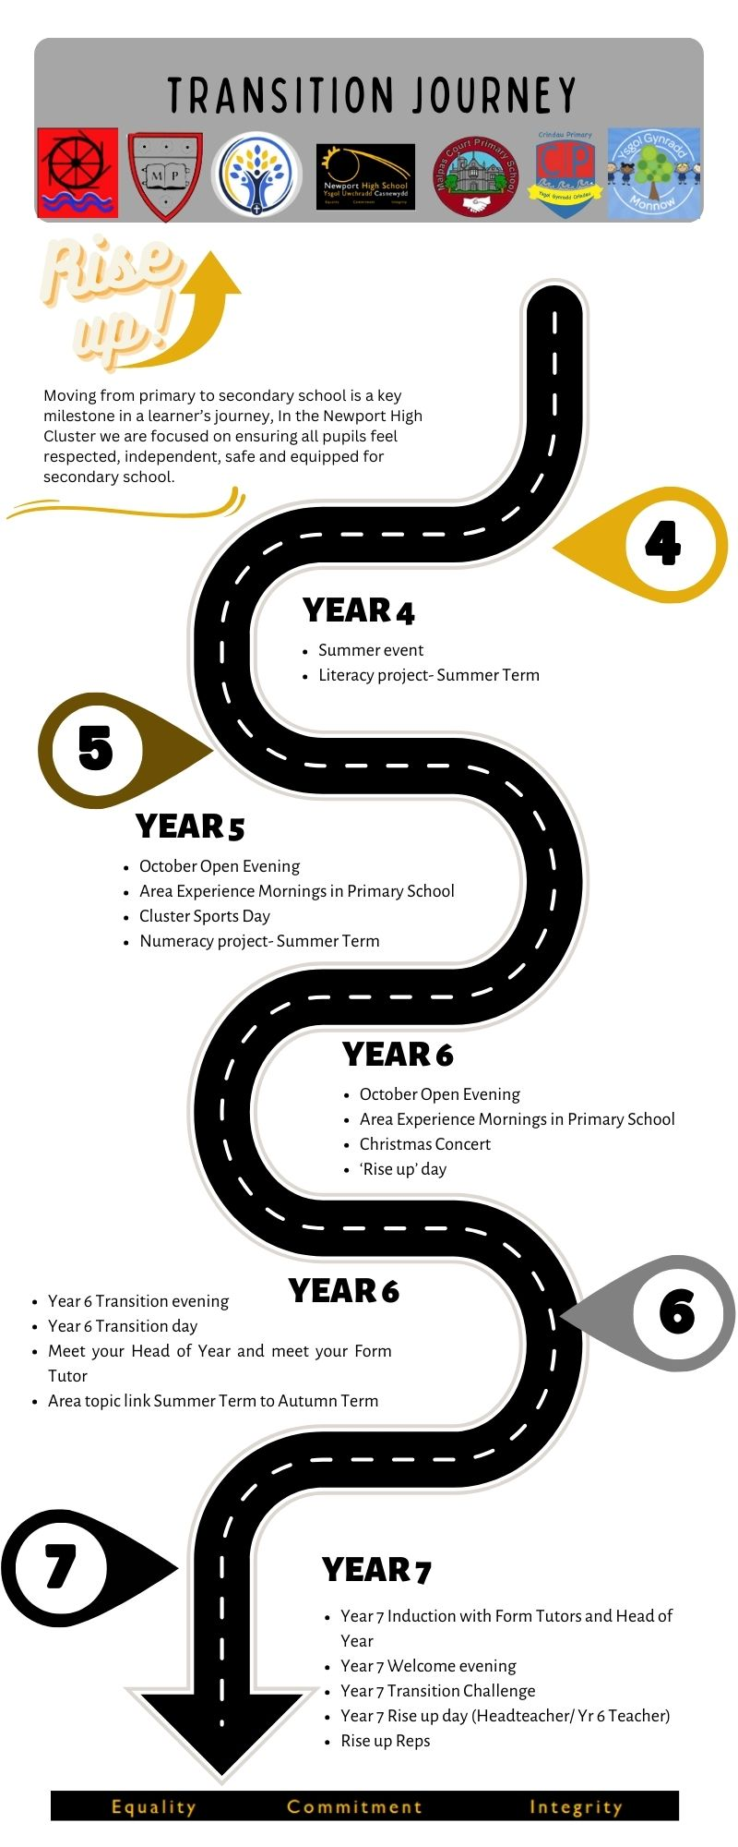

 | Core Content | Actions
Respecting learner and parent views in a person-centred transition process | Strategies for reviewing and monitoring impact of the implemented transition plan | - Utilise staff/parent and learner voice to acquire first hand evidence on impact  - Transition newsletter  - Transition page on website- regularly updated.  - Transition parent forum
Encouraging Independence through reflection and purposeful design | General proposals for continuity of learning through:  - curriculum design  - planning for teaching and learning | - Commitment from all cluster members to continued AOLE working groups and develop sub-committees  - AOLE working groups focused on shared understanding of progression. Groups to develop progression rubrics and progression portfolios for key concepts  - Identification of T&L leads in cluster schools  - Cluster professional learning opportunities through calendared Twilights  - AOLE transition days in Year 5 and Year 6
Ensuring safety and positive relationships | Identification of how learning needs and wellbeing of each learner will be supported | - Inclusion and Wellbeing sub-committees calendared:  -Cluster ALN  -Cluster Attendance  -Cluster Assessment and Progression  - Enhanced transition programme  - Transition days – AOLE experiences with Newport High School Area Leads  - Developing a cluster approach to anti-racist practice  - Joint Transition experiences – Year 5 Sports Day; open afternoons and transition social events  - Early contact/communication from Head of Year and potential Form Tutors  - Rise up Reps mentoring programme
Being ready and equipped to support | General proposals for managing and coordinating the transition of learners from Year 6 to Year 7 | - Continued calendared cluster headteacher meetings.  - Transition plan – common agenda item for each meeting  - Agreed transition cluster calendar for 2023.24  - Consistent communication strategies shared – termly cluster newsletter; Twitter account; calendar of key dates shared with parents in open evening  - Agreed sharing of information to support progression e.g. reading/spelling ages; NRNT; learning interventions; MAT learners; ALN support; wellbeing interventions  - Collaborative opportunities to support MAT/SEREN learners and ALN learners  - Year 6 handover meeting with Newport High School and Year 6 staff

