This guide has been created to help you and your child access home learning activities and digital resources.

With blended learning becoming more prominent in schools today, it is important to ensure that your child can access lessons and activities when we are required to work from home.
Below are instructions for accessing and using the most common digital learning platforms that we use at Malpas Court Primary School. Please don’t hesitate to contact us if you need any advice or support regarding online learning, or and hardware issues you might be facing.


- Class Dojo

Class Dojo is used throughout the school, as our primary way of sharing both class and whole school information. This includes activities to be done at home, photos of class activities and individual pupil profiles, as well as a direct message feature with your child’s class teacher.
To access Class Dojo, you will be given a unique login code for your child. The easiest way to access Class Dojo is by downloading the app to your phone or tablet. The app allows you to see the class and school story, message the teacher, see your child’s portfolio of work and their dojo points. In order to access activities and work set by your child’s teacher, you will need to login to the web version. When you set up the Class Dojo app, you will be asked to create your login details, these same details are used to access the website.
When you log in to Class Dojo, you will log into your parent account. From there you should see your child’s account. Selecting your child on the website will show any activities allocated to them, if you then click on that activity you should be able to edit it to complete the activity. (You will not be able to see the activities from your parent account.) Once the work is done, you can submit it to the teacher to look at. They will either add it to your child’s portfolio, or return it with a comment explaining any corrections. If it is not possible for your child to complete the work online, they can do the work on paper by copying the questions from dojo. Then you can send us a photograph of their finished work – either through their portfolio or messages.
Any work they complete at home can be sent to their teacher via Dojo. We love seeing what they are up to! We can add any images send through messages to your child’s portfolio.
There is lots of help and support for using Class Dojo via the link below:
https://classdojo.zendesk.com/hc/en-us/categories/200185365-For-parents


- Microsoft Teams

A lot of classes are using Microsoft Teams for virtual lessons. These lessons are always hosted by a member of staff and can only be accessed by people who have the link.
Microsoft Teams does have an app you can download to a phone, tablet, laptop or PC. The benefit of using the app is that your child can remain logged in without having to go through Hwb each time. But it doesn’t matter if you access it through the app or the web version.
Microsoft Teams can be found in Hwb. Your child will need to log into their Hwb account, go into the menu and select Office 365. This will open all of the Microsoft Office tools. Click on the Teams icon. Once you are in Teams, click the calendar option to show the calls you have been invited to, then click to join the call.
Teams gives you the option to join with your camera turned on or off. If you choose to keep your camera off, you can see everyone else but they can’t see you. It is also important to know how to mute and unmute the microphone. The children will be asked to go on mute to reduce background noise (and everyone talking at once!)
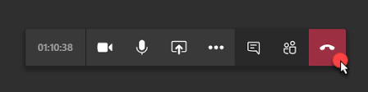
Camera on/off Microphone on/off Text chat End call

Staff are using Microsoft Teams to host wellbeing check in sessions where pupils can see each other virtually and have a chat. They are also using Teams to run virtual lessons, as staff can present work and examples on the screen for everyone to see and follow along. It is really beneficial for pupils to use these online sessions, both educationally and socially.
Microsoft Teams also has a built-in chat feature, where pupils can ask questions or respond to the teacher. Again, this chat can only be accessed by people who have the link and is monitored by staff.
If you are experiencing difficulties with Teams, it is worth downloading the app as that is slightly more reliable. Some people find that they are regularly ‘removed’ from calls – this is usually due to a lack of space on the device you are using. This can be solved by deleting unnecessary apps/ documents/ photos etc, or by closing as many online tabs as you can.
If you use Teams through the website, you may not be able to see everyone who is on the call, if that is the case, you will need to download the Teams App.


- Google Meet

Some classes are using Google Meet as an alternative to Microsoft Teams. Again, these online calls and chats can only be accessed by those who have the link, and are always hosted by members of staff.
There is a Google Meet app, but like Teams, it can be used through the website. If you are accessing online learning via Google Meet, please use the Google Chrome internet browser where possible – other browsers will not allow access to all of the Google features.

Google Chrome can be downloaded as an app to any mobile device. Use the Google App to access the internet. There are different ways to access Google Meet and it doesn’t matter which one you use. You can search for Google Meet, or you can click the Google ‘waffle’ icon at the top right side of the screen and scroll down to Google Meet. Alternatively, you might have the link in your child’s Google Classroom. However you choose to access it, you will need to log in with your child’s Hwb account details.
Once you are in Google Meet, or you have accessed the link via Google Classroom, you will have the option to join the call. As with Microsoft Teams, you can join with or without the camera on, and children will be asked to mute the sound to limit background noise.
Staff use Google Meet in the same way as Microsoft Teams. We can host wellbeing check in sessions, or use it to host lessons where we present our screen to pupils and explain the work to them.
Just as Microsoft Teams does, Google Meet also has a chat feature where pupils can ask questions or respond to the teacher.

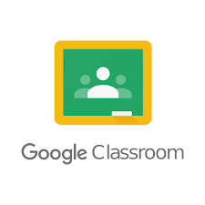
- Google Classroom

Google Classroom is a great digital learning platform, as it allows access to so many apps and features all in the one place!
To access Google Classroom, you will need to use Google Chrome to access the internet (for more information see the Google Meet instructions). You will not be able to access all of the Google features if you use a different browser!
You can access Google Classroom in the same ways as Google Meet, and you will need to log in with your child’s Hwb account details. Once you are logged in to Google Classroom, select your child’s class.
The ‘stream’ will show any work that has been added to Google Classroom, messages from the teacher and upcoming live session links.
‘Classwork’ will show all the work that has been allocated to your child (if your class teacher is using Google Classroom to issue work), it will show which activities are complete, which have not been done and any deadlines for returning the work. Work completed through Google Classroom can be seen and commented on by the class teacher. It can also be returned to the pupil if it is incomplete or needs correcting.
Work issued through Google Classroom is easier to complete and share if you use the Google tools (slides, docs, sheets etc). If you are unsure if your work has been uploaded, use the share option (usually on the top right of the screen) and add your class teachers email to send it directly to them.


- Hwb

Hwb is a digital learning platform used by a number of schools across Wales.
All pupils at Malpas Court Primary have their own unique login details for Hwb. Their Hwb accounts give them access to the Microsoft Office tools, Google Education Tools, JiT and J2E learning platforms.
The menu option once you are logged into Hwb will allow you to access all of these apps and platforms.
Within Microsoft Office, each pupil has their own email account in Microsoft Outlook. Pupils can communicate with staff using their Outlook email address or send photos of their completed work.
It is important for our pupils to be familiar with using this as a number of assessment tools are now done online through Hwb. Digital Literacy is an incredibly important skill now in regards to jobs and careers, it is something we are working on a lot in school across all year groups.

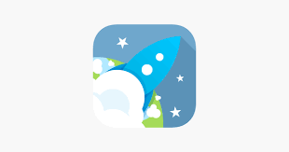

- J2E, JiT and J2E Office

J2E is an online learning platform with LOADS of interesting features! This is something we use in school, so the children should be familiar with how it works! JiT is aimed at younger children and is very easy to use, whereas J2E Office is similar to Microsoft Office. All the work completed in J2E is stored within their J2E file, which can be viewed and commented on by staff. J2E also allows staff to share documents and work with pupils, as well as pupils sharing work with each other and working collaboratively.
To access JiT, once you are logged into Hwb use the menu to select J2E and bring up the J2E options. Select JiT and use the options across the top of the page to move between the different features (writing, data, turtle, animation etc). Then use the save button to save their work.
Open Save Different Activities

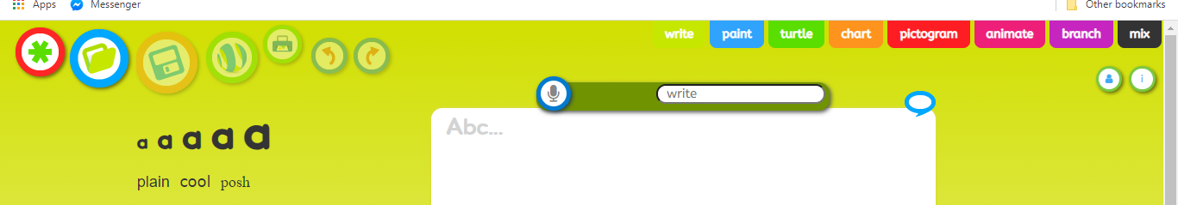
To access J2E Office, once you are logged into Hwb use the menu to select J2E and bring up the J2E options. Select J2E Office to bring up the options for writing, slides and spreadsheets. Once you have finished, click on ‘untitled document’ to change the name and it will save automatically.
To share work in J2E or JiT, once you are in the main J2E dashboard, select ‘my files’ and find the document you want to share. (Make sure you don’t have that document open already) Right click on the document and click ‘share’. Type the name of the person you want to share it with and select ‘add’ to send it to them.
J2E also allows staff to have learning conversations using the speech bubble icon on each document. Pupils can also make comments in the speech bubble, or ask questions to further their learning.
J2E is also available to download as an app called J2E Launch.

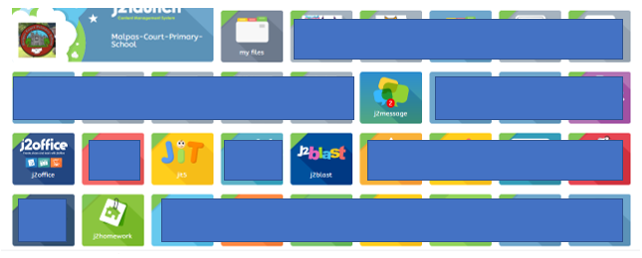
Some classes (mainly Foundation Phase), are putting assigned work and activities in the ‘j2homework’ tab. When you click this option, it will bring up all of the work assigned to your child. Click on the activity to open it and complete the work straight on the document. This will then save in the ‘my files’ tab, where teachers can mark it and give feedback.
Office tools Homework JiT j2blast – maths games
Pupils work stored in ‘My Files’ Instant messaging feature per class

- Document Sharing and Email Attachments
Google –
If you are working in Google Suite, there is an option at the top of the screen on the right that says ‘share’. Select this and enter the email address of the person you want to send your work to and click share. Once you have shared the document once, there is no need to reshare it if you make any changes. Sharing Google documents also allows pupils to work on something at the same time, allowing them to collaborate with a partner or in groups.

Email Attachments – If you have produced work in Microsoft Office (but not through Hwb), or have other documents or photos to share, this can be done as an email attachment. Ensure the document you want to share has been saved to your device or hard-drive and has a suitable name (so you know you are attaching the right thing!). Open your emails and create a new one. Add the email address you want to send it to and a subject title. Below the blank space where you would type your email, there is (usually) an image of a paperclip. Select this and then click on the file/ document you want to share. It should show the attachment on the email, and then you can click ‘send’.
Add email attachment logo



- Mathletics and Bug Club

Mathletics and Bug Club are both online learning tools that the children can access in school and at home. Each child has their own login details for these.

Mathletics – This is an online platform that focuses on maths skills and activities. Login through their homepage to bring up your child’s account and view their progress. Mathletics can be accessed on most devices that have internet access.
Bug Club – When you search for Bug Club online, it will come up as ‘Active Learn Primary’. Select this one and log in. Every pupil has a range of digital books and reading comprehension activities allocated to them, based on their reading level. Work completed and books read can be accessed by the staff, allowing them to give feedback and assign new books.
Bug Club can be accessed on laptops, PCs, iPads and some Android devices. It is not currently available on kindle or some older Android phones and tablets. If you are having difficulty accessing Bug Club, check that your software is updated to the latest version. (Check your software version in your phone or tablets ‘settings’. Update if it asks you to. Older devices may not be able to access Bug Club if they cannot download the up-to-date software.)

- Storage (Device and Cloud)

You have a number of options when it comes to digital storage. Electronic devices have a set amount of storage space, this is used to save photos, documents, internet cookies, Bluetooth cache as well as needing free space to run apps and tools. If you do not have enough free space, your device will be slow and may not work correctly. There are many ways to keep space free on your device;
- Delete unnecessary photos, music, videos, documents, Apps etc. Everything you save to your device takes up space. If you don’t need it, delete it!



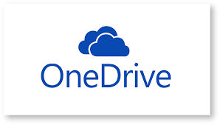
- Save photos, videos, documents etc to a cloud storage platform. Most phones and mobile devices come with some form of cloud storage – this allows you to access and share your photos and documents etc, without them taking up space on your device. If you have an Apple device, you will have access to the iCloud. Apple devices usually upload unused files and photos to the iCloud automatically (you can check if your device does this in the ‘settings’. If you have an Android device you may not have cloud storage included. There are a number of safe and reliable cloud storage options that will work on any device. Dropbox is a well know cloud storage and file sharing platform. Basic accounts are free and come with 2GB of storage. Set up an account online or through their mobile app. Google Drive offers 15GB of storage for free. Again, you can create an account online or through the Drive App. (The benefit of using Google Drive, is that a lot of people use it so it’s easy to share photos and documents with others. It is easy to use and work can be moved between different Google tools making it very flexible.) One Drive with Microsoft comes with 5GB of free storage. All pupils have access to both Google Drive and One Drive through their Hwb accounts. Cloud storage platforms usually offer alternative plans too, where you can access more storge space for a small fee every month. All Cloud storage platforms work in the same way. To save files/ photos/ videos etc to a cloud platform, login to your account (or access the app), then look for the ‘upload’ or ‘add’ option. It will then ask you to select the file/s you want to upload. Once they have been uploaded to the Cloud, you can delete then from your device. If you need to download the file/ photo/ video etc, access your Cloud storage, select the file you want to add to your device and select ‘download’. This will re-save it onto your device.

- Clear your internet browser history. Not only is this good practice in regards to privacy, but it’s another thing taking up space on your device! In your web browser there should be settings at the top (usually on the right-hand side), where you will find ‘history’. Select ‘clear history’ or ‘clear all time’ to erase all of the sites stored there. With Android devices, go into your main settings and choose Apps/ App Manager. Select your internet browser, then ‘clear data’ and ‘clear cache’. With Apple devices, go into your main settings and select your internet browser. Select ‘clear cookies and data’ or ‘clear cookies and cache’.

- If you regularly use your devices Bluetooth, you may be able to free up some space by clearing the Bluetooth cache (sometimes your device will not work correctly if your Bluetooth cache needs emptying). In the same way as clearing your internet history, in your devices main settings select Bluetooth. Select ‘storage’ and then ‘clear cache’. (If you don’t use your Bluetooth, it is worth turning it off as it drains your battery!)

- Turn off your devices regularly. It sounds simple, but a surprising number of people leave their phones and tablets on 24/7! Electronic devices need to be switched off at least once a week – even if it’s just for an hour. This allows your device to shut everything down correctly and ‘clean up’. It also helps to preserve your devices battery life.



- Alternative Internet Access



There are other devices that allow you to access the internet.
- Nintendo 3DS – While it’s not the best way to access the internet, it is possible if you have Wi-Fi! In your devices ‘system settings’, select ‘internet settings’ then ‘connection settings’. Select a ‘new’ connection. Your 3DS will ask if you want to connect manually, or if you want a tutorial. Then you will need to ‘search for an access point’ (which is your Wi-Fi connection). Select your Wi-Fi and enter your Wi-Fi password to connect.
- Amazon Kindle Fire – If you have a Kindle Fire, it probably has the ‘Silk’ browser pre-installed. Ensure your device is connected to your Wi-Fi (In your devices settings, select your wi-fi and enter your password.) and access the internet as you would on a tablet. The internet browser may not be visible if you have the parental control settings on. Not all websites and functions can be accessed through the Kindle Fire, as that is not its main function. (To prolong your Kindle Fire battery, turn the Wi-Fi off when you are not using it. You won’t need to re-enter your password every time you turn it on as your device will remember it.
- X-box – Microsoft Edge Browser should come pre-installed on the X-Box. (If not, you can re-download it from the Apps section in the store) Use your left analogue stick to control the ‘mouse pointer’ and the right stick to control the scrolling. You will need an X-box Live account to access the internet.
- PlayStation – On the main content area, scroll across until you come to ‘Internet Browser’. Press ‘X’ to open the browser. You will need a PlayStation Network account to access the internet.


- Teach Your Monster to Read

Teach Your Monster to Read is a programme that supports the children with phonics and reading. We use this primarily in Foundation Phase. This is not our main phonics scheme in school, but the children use it independently to support their learning and to work their way through the stages.
You will be given a username and star code.
There are two ways to log in.
- Google ‘Teach Your Monster to Read’.
- Type in the URL with the star code.

Google Teach Your Monster to Read
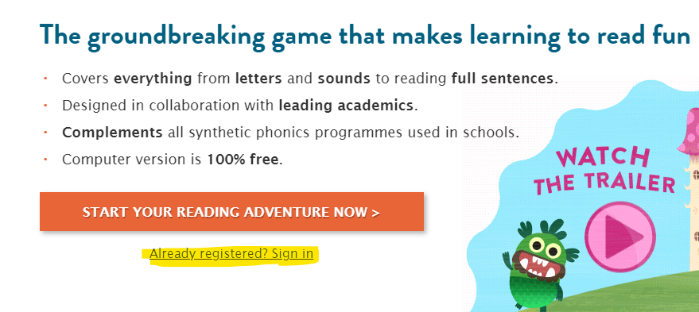
When you type it into Google, select the first link and it will take you to the home page.
Scroll down until you see the example on the right, then click on ‘Already Registered’.

This will take you to the page where you type in your child’s username and star code, which can be found on their login card.
Type it straight into the URL (Web address bar).
You can type in the following URL https://www.teachyourmonstertoread.com/u/ followed by the star code. E.g. https://www.teachyourmonstertoread.com/u/123456
This will take you to the login page, where you type in your child’s username.

